Below is my project which I am going to build as executable jar.
I have placed all the jars which I used for the project within the JAR folder inside my project workspace and I added those jars into the buildpath directly from JAR folder. so that the dependency on jars will not be affected.

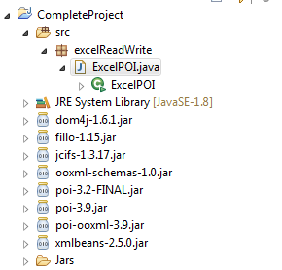
The above project will open the excel file and write the content into it and read the excel sheet.
Here the file name path is not hardcoded,rather it is passed as arguments.

Here is my complete Project code snippet,

package excelReadWrite;
import java.io.File;
import java.io.FileInputStream;
import java.io.FileNotFoundException;
import java.io.FileOutputStream;
import java.io.IOException;
import java.util.Iterator;

import javax.swing.table.DefaultTableCellRenderer;

import org.apache.poi.ss.usermodel.Cell;
import org.apache.poi.ss.usermodel.Comment;
import org.apache.poi.ss.usermodel.Row;
import org.apache.poi.ss.usermodel.Sheet;
import org.apache.poi.ss.usermodel.Workbook;
import org.apache.poi.xssf.usermodel.XSSFCell;
import org.apache.poi.xssf.usermodel.XSSFSheet;
import org.apache.poi.xssf.usermodel.XSSFWorkbook;

@SuppressWarnings("serial")
public class ExcelPOI extends DefaultTableCellRenderer {
public static void main(String[] args) throws IOException
{
String FILE_NAME = args[0];
ExcelPOI t=new ExcelPOI();
t.WriteExcel(FILE_NAME);
t.readExcel(FILE_NAME);
}
private void readExcel(String FILE_NAME)
{
try {
FileInputStream excelFile = new FileInputStream(new File(FILE_NAME));
Workbook workbook = new XSSFWorkbook(excelFile);
Sheet datatypeSheet = workbook.getSheetAt(0);
Iterator<Row> iterator = datatypeSheet.iterator();

while (iterator.hasNext())
{
Row currentRow = iterator.next();
Iterator<Cell> cellIterator = currentRow.iterator();

while (cellIterator.hasNext())
{
Cell currentCell = cellIterator.next();
//getCellTypeEnum shown as deprecated for version 3.15
//getCellTypeEnum ill be renamed to getCellType starting from version 4.0
//XSSFCell.CELL_TYPE_BLANK,XSSFCell.CELL.TYPE_BOOLEAN,XSSFCell.CELL_TYPE_ERROR
if (currentCell.getCellType() == XSSFCell.CELL_TYPE_STRING)
{
System.out.print(currentCell.getStringCellValue() + "<-->");
}
else if (currentCell.getCellType() == XSSFCell.CELL_TYPE_NUMERIC)
{
System.out.print(currentCell.getNumericCellValue() + "<-->");
}
String cellComment= readCellComments(datatypeSheet,currentCell.getRowIndex(),1);
System.out.println(cellComment);
}
System.out.println("");
}
workbook.close();
} catch (FileNotFoundException e) {
e.printStackTrace();
} catch (IOException e) {
e.printStackTrace();
}
}
private String readCellComments(Sheet sheet,int rowNum,int colNum) {
Comment cmt = sheet.getCellComment(rowNum,colNum);
String data=null;
if (cmt != null)
{
data = cmt.getString().toString();
}
return data;
}
private void WriteExcel(String FILE_NAME)
{
//XSSF for xlsx, HSSF for xls and xlsm
XSSFWorkbook workbook = new XSSFWorkbook();
XSSFSheet sheet = workbook.createSheet("Employee Details");
Object[][] datatypes = {
{"ID", "Name", "Technology"},
{1, "Kirthi", "Java"},
{2, "Manju", "Oracle"},
{3, "Pavi", "DOtNet"},
};
int rowNum = 0;
for (Object[] datatype : datatypes) {
Row row = sheet.createRow(rowNum++);
int colNum = 0;
for (Object field : datatype) {
Cell cell = row.createCell(colNum++);
if (field instanceof String) {
cell.setCellValue((String) field);
} else if (field instanceof Integer) {
cell.setCellValue((Integer) field);
}
}
}
try {
File f=new File(FILE_NAME);
if(f.exists()){f.delete();}
FileOutputStream outputStream = new FileOutputStream(f);
workbook.write(outputStream);
workbook.close();
} catch (FileNotFoundException e) {
e.printStackTrace();
} catch (IOException e) {
e.printStackTrace();
}
System.out.println("Excel Created");
}

}

Once project is ready to build,right click on project ->Export -> Java -> Runnable JAR File.

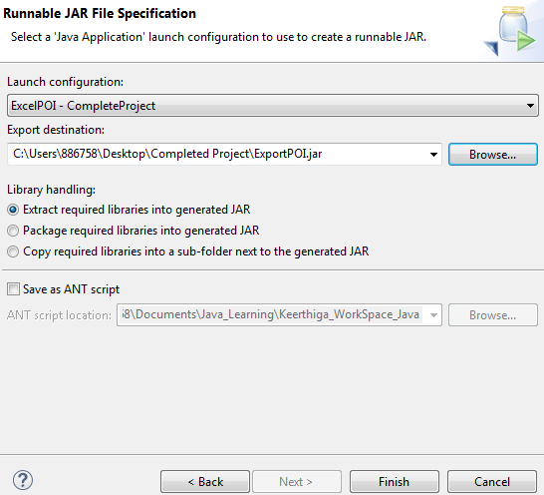
From Launch Configuration dropdown, select your project class name. And in export destination select the folder where it has to be export, and give the name for the jar file.and click on Finish.

Once the process is done, you can find your application jar in the folder you selected.

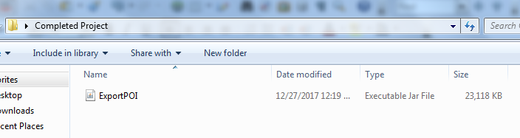

We can run the project via two ways,

1. Command Prompt,
- Bat file.

Via Comand Prompt

I have created a new excel sheet named outputExcel.xlsx inside the folder where jar is present.

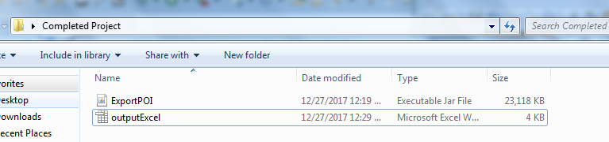

Here is the command to run through cmd prmpt,

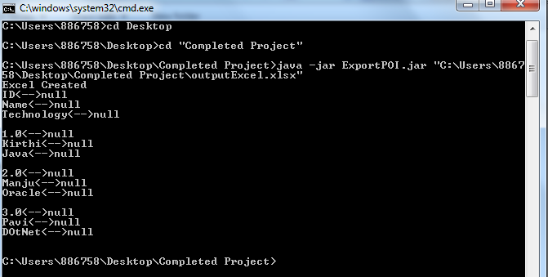

note: input file path which we have to be passed as argument will be passed here within double quotes as java -jar ExportPOI.jar "C:\Users\886758\Desktop\Completed Project\outputExcel.xlsx"

Here is the output in excel sheet,
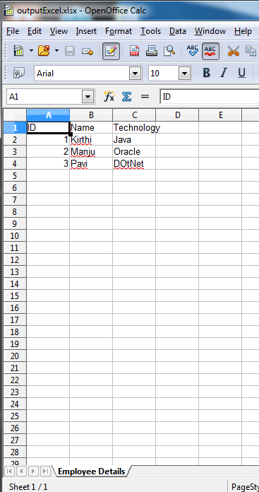
Via Bat file:

- I have created a new excel sheet named output.xlsx inside the folder where jar is present.
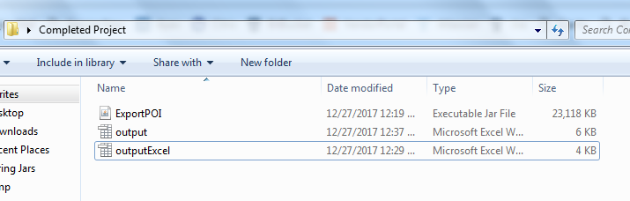
- Create a Bat file inside the folder where the project jar is present.
- create a new text document inside the folder,
- enter the below command inside the text file,

@echo off
set LOGFILE=batchError.log
call :LOG > %LOGFILE%
exit /B

echo %cd%
:LOG
java -jar ExportPOI.jar "%cd%\output.xlsx"

note: input file path which we have to be passed as argument will be passed here within double quotes as java -jar ExportPOI.jar "%cd%\output.xlsx". Here %cd% will take the path of the current location where the batfile is present.

3.Save the text file as Batfile.bat
4.To run the project, right click on Batfile and Run as administrator.

Once the project run completed, we can see a batchError file created to log the console logs or outputs.

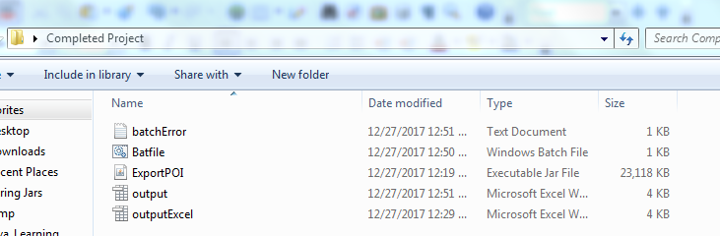

Ouput on console can be found on batchError file.

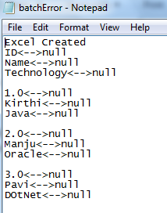

Here is the output in excel sheet,

